**Analyzing Non Functional aspect of transactions, soft lock, hard lock over normal Read/Write Operations in different data stores**

### **BITS ZG628T: Dissertation Final Submission**

by

Saurabh Araiyer

2017HT12225

# **Dissertation work carried out at**

## **Flipkart, Bangalore**



**BIRLA INSTITUTE OF TECHNOLOGY & SCIENCE**

**PILANI (RAJASTHAN)**

February 2019

**Analyzing Non Functional aspect of transactions, soft lock, hard lock over normal Read/Write Operations in different data stores**

### **BITS ZG628T: Dissertation Final Submission**

by

Saurabh Araiyer

2017HT12225

# **Dissertation work to be carried out at**

## **Flipkart, Bangalore**

Under the Supervision of

Vishwajith Bharadwaj, SDE-3

Flipkart Bangalore



**BIRLA INSTITUTE OF TECHNOLOGY & SCIENCE**

**PILANI (RAJASTHAN)**

April, 2019

**Birla Institute of Technology & Science, Pilani**

**Work-Integrated Learning Programmes Division**

**Second Semester 2018-2019**

**BITS ZG628T : Dissertation End Sem Submission**

**ID No. :** 2017HT12225

**NAME OF THE STUDENT :** Saurabh Araiyer

**EMAIL ADDRESS :** araiyersaurabh@gmail.com

**STUDENT’S EMPLOYING :** Flipkart

**ORGANIZATION & LOCATION**

**SUPERVISOR’S NAME :** Vishwajith Bharadwaj

**SUPERVISOR’S EMPLOYING :** Flipkart

**ORGANIZATION & LOCATION**

**SUPERVISOR’S EMAIL ADDRESS :** vishwajith.b@flipkart.com

**DISSERTATION TITLE :** Analyzing Non Functional aspect of transactions, soft lock, hard lock over normal Read/Write Operations in different data stores

# 

**Acknowledgements:**

I would like to thank BITS Pilani and Faculty mentors provided by BITS Pilani WILP division and Prof R Gururaj for giving me this opportunity to work on this formal project which may help the readers in decision making for making the right choice of Database Management System. Without their input, motivation and guidance, the project would not have been possible at all.

I would like to thank my organization for providing me with an opportunity of working on multiple data stores and informed colleagues who are able to help me in case of any roadblocks.

I would like to thank Arun Thulsidharan, Vishwajith Bharadwaj for helping in shaping this progress report of dissertation work, without their critical feedback and guidance this would not be possible

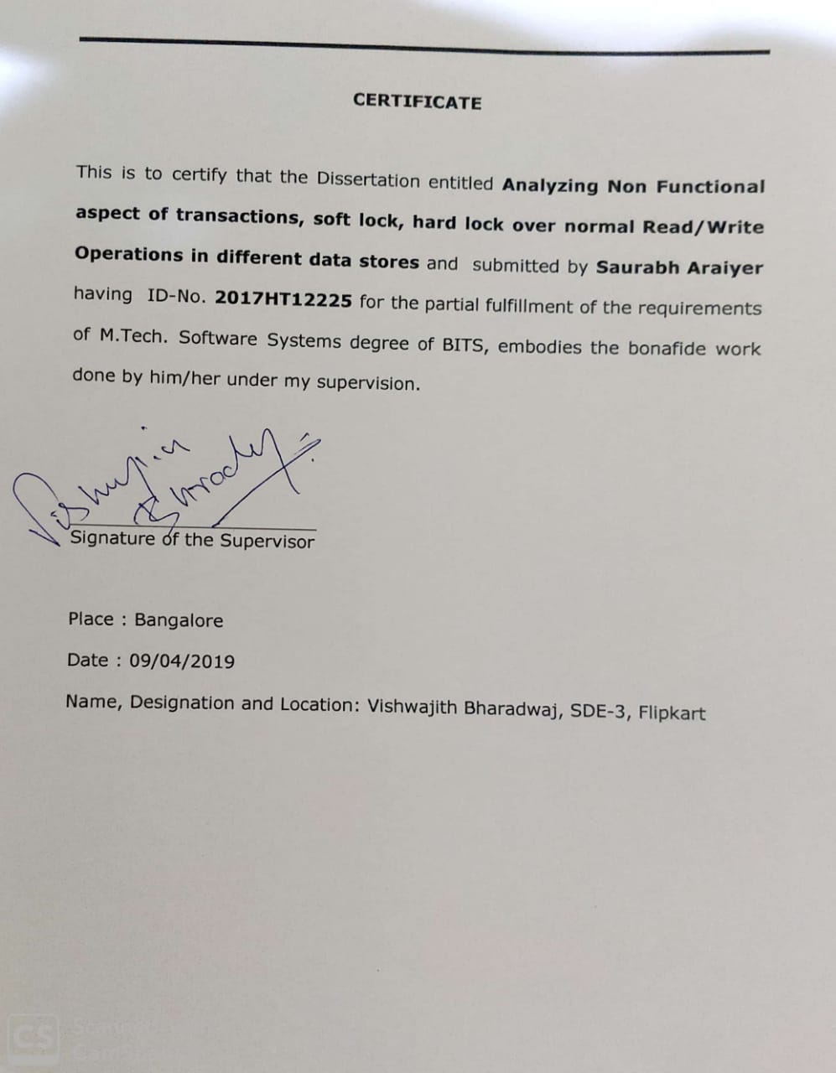

Table of Contents

1.Chapter 1: Background 1

2.Chapter 2: Objective 2

3.Chapter 3: Scope of Work 3

4.Chapter 4: Main Text4

4.1 Reason for Selecting 4

4.1.1 Different MySQL Engines (Table 1)5

4.2 Test Bench Description: 7

4.3 Trigger Interface: 7

4.4 Technologies used: 8

4.5 Platform: 8

4.5 General Configuration used for Test: 8

4.6 Algorithms for load generation: 9

5. Observations10

5.1 MySQL Test (Table 2-5)10

5.1.1 InnoDB10

5.1.2 MyISAM11

5.2 RMQ Test (Table6-9)11-12

5.3 Elasticsearch (Table 10-11)13

6. Conclusion 13

7. Literature References14

**Abstract:**

Today’s industry is ruled by data, and how we handle data. There are battles over data and whole companies built around it. In layman’s terms data stores can be classified into two categories: OLTP and OLAP. Before we jump on to any database choices, we need to skin down our requirements and look for the specific set of features we may be needing to be supported by a data store. For example a data store like redis can provide thousands of read per second, but it would not be useful when we try to make reservation systems with it. On the other hand, MySQL may provide very accurate transaction processing.

This work is mostly around getting a set of data to help us decide on what to choose when.

**Technical Keywords**: Java, Elasticsearch, ORM, Hibernate, Dropwizard, REST, NFR, Load Test

**Chapter 1: Background:**

1. As per the definition, Non-Functional attributes are the quality attributes of a system. One of the quality attributes is queries per second we are able to execute on a given infrastructure.
2. Transactions are one of the most important operations which we perform on a data store. And because of the constraints, particularly ACID properties, in case of a single system, problems are not so difficult. But when we consider distributed systems, another level of problem comes.

There are many data stores which natively support transaction like innodb engine of MySQL, transaction channel RMQ etc (however in RMQ, full ACID properties are not supported as of date). And some very widely used data stores like HBase doesn’t even support transaction properties. So using a distributed locking

Considering importance of transaction, it is very important to compare different data stores in order to trigger the appropriate decision-making metrics.

1

**Chapter 2: Objective:**

Main objective of this activity is to explore the limiting factor (in terms of system resources like CPU, Memory) in three scenarios:

1. Normal Read/Write operations
2. Read/Write operations with locking. Locking can be of two types:
   1. Hard lock, where if a row is locked then it is not available for reading as well
   2. Soft lock, a lock doesn’t block read access to the data store

To achieve the above goals, there would be a need to automate, learn interactions with different data stores, and explore workarounds to enable some properties of a transaction in data stores which do not support it natively. Also since with the increase in scale of systems, distributed transactions also come into picture, I would attempt to simulate and try to tackle those problems to some extent.

2

## **Chapter 3: Scope of Work:**

This would be limited to automation of load test bench in form of Java microservices, metrics collection, information gathering from load test result and finding a logical relation among throttling factors for our experiment. This applications covers the applications and data stores in breadth with shallow load testing. The application is written in a way that complex queries could be supported with minimal changes to current code.

Github Link: <https://github.com/saurabhsar/dissertation/>

3

**Chapter 4: Main Text:**

1. Choosing the data stores to test, learning interactions with them and automate the load generation process to verify
   1. The work is based on automating load generation on MySQL, RabbitMQ, Elasticsearch

**Reasons for selecting**:

1. MySQL: It is the most popular data store used currently. It provides many kinds of engine for different use cases. Those are explained separately
2. RabbitMQ: This is a distributed Queue.
3. Elasticsearch: This is a no-SQL document store it supports REST based queries, This is written on top of Apache Lucene. Currently it is one of the most popular document based free data store in the industry.

I tried to chose the data stores which describe cover a wide spectrum of use cases

1. Exploring the transaction aspect of those data stores, if they do not support transaction then try to find workaround for them. If partial support for ACID properties are there, create a test bench to test those partial properties.

4

* 1. Of the above stores, Only MySQL supports full ACID property in one engine.
  2. RabbitMQ supports transaction channel, by this it means that in case of multiple queue publish it would help. But it doesn’t support basic ACID properties.
  3. Elasticsearch is primarily designed for search based purposes so this doesn’t support any ACID properties.

1. Find, compare the data with and without transaction
2. If possible, try to simulate above problems in different environment like SSD, Rotating Disk etc. (If possible because some data stores like aerospike are meant only for SSD and do not support rotating disk)
3. For distributed transaction, try to simulate a failure scenario and if possible implement a workaround

Observe and summarize so that it can be helpful for a proper decision making matrix.

**1.a.1: Different MySQL Engines**

1.a.1.1: **InnoDB**: This is the default storage engine in most versions of MySQL. InnoDB is a (ACID compliant) data store. Operations supported by InnoDB are commit, rollback, and crash-recovery capabilities. InnoDB supports row-level locking and Oracle-style consistent nonlocking reads which

5

helps increase in multi-user concurrency and performance. InnoDB stores user data in clustered indexes which helps in reducing I/O for common queries based on primary keys. InnoDB also supports FOREIGN KEY referential-integrity constraints which helps in maintaining data integrity.

1.a.1.2: **MyISAM:** These tables have a small memory footprint as compared to InnoDB. This engine is preferred in read-only or read-heavy workloads in Web and data warehousing configurations. Table lock, which is supported by MyISAM prevents transactions from accessing a particular table.

1.a.1.3: **Memory**: This engine stores all the data in RAM for fast access in environments needing quick lookups of non-critical data. Earlier, this engine was known as HEAP engine.

1.a.1.4: **CSV**: They are text files with comma-separated values. CSV tables let us import or dump data in CSV format. Since CSV tables are not indexed, it is a general practice to keep in InnoDB tables during normal operation, and only using CSV tables during the import or export stage.

1.a.1.5: **Blackhole**: This engine accepts the data but does not store, its behavior is similar to the *nix /dev/null device. Since no data is stored, search

6

queries would always return an empty set. These tables are generally used in replication with query-based replication where DML statements are sent to slave servers.

There are many other engines like Archive, NDB, Merge, Federated, Example

Table 1: As a summary, source[Table 16.1, https://dev.mysql.com/doc/]

|  |  |  |  |  |
| --- | --- | --- | --- | --- |
| **Feature** | **MyISAM** | **Memory** | **InnoDB** | **Archive** |
| ***B-tree indexes*** | Yes | Yes | Yes | No |
| ***Backup/point-in-time recovery*** | Yes | Yes | Yes | Yes |
| ***Cluster database support*** | No | No | No | No |
| ***Clustered indexes*** | No | No | Yes | No |
| ***Compressed data*** | Yes | No | Yes | Yes |
| ***Data caches*** | No | N/A | Yes | No |
| ***Encrypted data*** | Yes | Yes | Yes | Yes |
| ***Foreign key support*** | No | No | Yes | No |
| ***Full-text search indexes*** | Yes | No | Yes (note 6) | No |
| ***Geospatial data type support*** | Yes | No | Yes | Yes |
| ***Geospatial indexing support*** | Yes | No | Yes (note 7) | No |
| ***Hash indexes*** | No | Yes | No (note 8) | No |
| ***Index caches*** | Yes | N/A | Yes | No |
| ***Locking granularity*** | Table | Table | Row | Row |
| ***MVCC*** | No | No | Yes | No |
| ***Replication support*** | Yes | Limited (note 9) | Yes | Yes |
| ***Storage limits*** | 256TB | RAM | 64TB | None |
| ***T-tree indexes*** | No | No | No | No |
| ***Transactions*** | No | No | Yes | No |
| ***Update statistics for data dictionary*** | Yes | Yes | Yes | Yes |

**Test Bench Description**:

All the tech stacks/design patterns used in the development of this test bench are generally followed in industry. This bench is made in such a manner so that new databases are easily onboardable. And if needed, this can be used to benchmark different Databases as per the use case.

**Trigger Interface**: REST API’s

**Technologies used**: Java, Dropwizard, Hibernate for ORM Based connection, Jersey Rest API’s

**Platform**: Mac OS X

**General Configuration used for test:** threads: 5, test ran for 5 seconds

8

Sample Request curl for triggering test:

curl -i -X POST \

-H "Content-Type:application/json" \

-d \'{ "threads" : 5, "load" : 1, "timeInMilis" : 1000, "transactional" : false, "durable" : true, "requestType": "READ"}' \

'http://localhost:1730/test/gen-load/mysql'

Algorithms for load generation:

**For RabbitMQ and Elasticsearch**:

Depending on the request, desired number of threads are created and then it hits data-store parallely. Since RabbitMQ supports transaction channels, the request has a boolean value isTransactional and tries to write to queues on the basis of this configuration.

**For MySQL**:

Hibernate ORM of MySQL works on SessionContext. So every request which comes to the application is bound by sessionContext. And all the requests would be written to database on successful response from the application. So this would be effectively giving the first phase of commit which has happened in ORM. The Second phase commit (actual commit to DB) which is costly and involves disk operation would be delayed, hence not giving the

9

proper number.

To counter the above problem, the load generator, instead of calling MySQL directly, it calls an internal API which is bound by SessionContext (for transactional capabilities) and writes to MySQL on a successful return.

The observations are marked in yammer metrics.

**Observations:**

**Table 2: MySQL Write: (InnoDB)**

|  |  |  |  |
| --- | --- | --- | --- |
| **Test #** | **Time (in ms)** | **versioned** | **Count of operation** |
| 1 | 5005 | No | 3680 |
| 2 | 5003 | No | 3318 |
| 3 | 5000 | Yes | 4705 |
| 4 | 5008 | Yes | 4158 |

**Table 3: MySQL Read: (InnoDB)**

|  |  |  |  |
| --- | --- | --- | --- |
| **Test #** | **Time (in ms)** | **versioned** | **Count of operation** |
| 1 | 1005 | No | 2599 |
| 2 | 1003 | No | 2621 |
| 3 | 1003 | Yes | 2253 |
| 4 | 1004 | Yes | 2104 |

10

**Table 4: MySQL Write: (MyISAM)**

|  |  |  |  |
| --- | --- | --- | --- |
| **Test #** | **Time (in ms)** | **versioned** | **Count of operation** |
| 1 | 5000 | No | 5046 |
| 2 | 5001 | No | 4935 |
| 3 | 5000 | Yes | 5602 |
| 4 | 5001 | Yes | 5274 |

**Table 5: MySQL Read: (MyISAM)**

|  |  |  |  |
| --- | --- | --- | --- |
| **Test #** | **Time (in ms)** | **versioned** | **Count of operation** |
| 1 | 5005 | No | 3512 |
| 2 | 5003 | No | 3204 |
| 3 | 1003 | Yes | 2451 |
| 4 | 1004 | Yes | 2395 |

**Table 6: RMQ READ (Without disk persistence):**

|  |  |  |  |
| --- | --- | --- | --- |
| **Test #** | **Time (in ms)** | **transactional** | **Count of operation** |
| 1 | 10001 | No | 33274 |
| 2 | 10905 | No | 40901 |

11

**Table 7: RMQ Write (Without disk persisted messages):**

|  |  |  |  |
| --- | --- | --- | --- |
| **Test #** | **Time in ms** | **transactional** | **Count of operation** |
| 1 | 10010 | No | 323,419 |
| 2 | 10009 | No | 315,017 |
| 3 | 10100 | Yes | 17,336 |
| 4 | 10054 | Yes | 18,547 |

**Table 8: RMQ Write (With disk persistence):**

|  |  |  |  |
| --- | --- | --- | --- |
| **Test #** | **Time (in ms)** | **transactional** | **Count of operation** |
| 1 | 10200 | No | 153,964 |
| 2 | 10108 | No | 156,398 |
| 3 | 10093 | Yes | 354 |
| 4 | 10110 | Yes | 392 |

**Table 9: RMQ Read (disk persisted):**

|  |  |  |  |
| --- | --- | --- | --- |
| **Test #** | **Time (in ms)** | **transactional** | **Count of operation** |
| 1 | 10001 | No | 30560 |
| 2 | 10905 | No | 31294 |

12

**Table 10: Elasticsearch Write: (With HTTP Client)**

|  |  |  |
| --- | --- | --- |
| **Test #** | **Time (in ms)** | **Count of operation** |
| 1 | 10007 | 689 |
| 2 | 10041 | 676 |
| 3 | 10105 | 678 |
| 4 | 20041 | 1303 |

**Table 11: Elasticsearch Read: (With HTTP Client)**

|  |  |  |
| --- | --- | --- |
| **Test #** | **Time (in ms)** | **Count of operation** |
| 1 | 1004 | 72 |
| 2 | 1001 | 70 |
| 3 | 1010 | 82 |
| 4 | 1031 | 78 |

13

**Conclusion and Direction of Future work**

The main focus of this project was to enable the load testing of different databases in different scenarios. Currently this is focused on insertion and lookup. As the code has been open sourced on github, we can add more databases and more scenarios.

Looking into the data, wherever durability was involved there was a clear difference in normal query per second and durable query per second. In case of MySQL, although the engines are made for different purposes, but at the small scale of test which I was performing showed very minimal difference, so for small use cases having a MySQL would not hurt and transaction guarantees would be a bonus. For me, the strangest part was getting low qps from Elasticsearch. Elasticsearch is designed for environments needing different kinds of querability support like range based, absolute etc. But in the test environment it was outperformed by all the databases, even MySQL. For testing it’s true potential, an appropriate distributed environment may be reuqired with multiple shards and nodes. Also range of data was limited to some thousands which might have led to hotspotting.

As this is very relevant to my work environment, I would be maturing the test bench to at least one-two more databases and introduce the query involving altering current data for currently onboarded databases.**Literature References:**

1. <https://dev.mysql.com/doc/refman/8.0/en/>
2. <https://www.rabbitmq.com/semantics.html>
3. <https://www.aerospike.com/docs/architecture/acid.html>
4. <https://en.wikipedia.org/wiki/Distributed_transaction>
5. <https://lucidworks.com/2013/08/23/understanding-transaction-logs-softcommit-and-commit-in-sorlcloud/>
6. <https://docs.oracle.com/javacomponents/jmc-5-4/jfr-runtime-guide/about.htm#JFRUH170>
7. <https://en.wikipedia.org/wiki/ACID_(computer_science)>
8. <https://en.wikipedia.org/wiki/Non-functional_requirement>
9. <https://dzone.com/>
10. <https://stackoverflow.com/>
11. <https://docs.oracle.com/javase/7/docs/technotes/guides/management/jconsole.html>
12. <https://www.dropwizard.io/1.3.9/docs/>
13. <https://hibernate.org/orm/>
14. <https://www.elastic.co/>
15. <https://www.elastic.co/guide/index.html>

**Particulars of Supervisor and Examiner**

|  |  |  |
| --- | --- | --- |
|  | **Supervisor** | **Examiner** |
| **Name** | Vishwajith Bharadwaj | Arun Thulsidharan |
| **Qualification** | B-Tech | B-Tech |
| **Designation** | SDE-3 | SDE-3 |
| **Employing Organization and Location** | Flipkart, Bangalore | Hevo, Bangalore |
| **Phone No** | 8861982583 | 9632244339 |
| **Email address** | vishwajith.b@flipkart.com | arun@hevodata.com |
| **Date** | 08/04/2019 | 08/04/2019 |

14

